**CLOUD DEPLOY**

**What is GCP Cloud Deploy?**

GCP (Google Cloud Platform) Cloud Deploy is a tool that helps you **automatically deliver and update your applications**. It’s designed to make the process of moving your code from development (where you build it) to production (where users can access it) easier and faster, especially for applications running in **Kubernetes** (a system used for managing containerized applications).

**How GCP Cloud Deploy Works (In Simple Terms)**

1. **Delivery Pipelines**:
   * Think of this like a step-by-step path that your code follows as it moves from one environment (like testing) to another (like production).
2. **Releases**:
   * Each time you update your app, you create a "release." This release will then be moved through the pipeline and deployed.
3. **Targets**:
   * These are the places where your app will run, like different environments (e.g., **test**, **staging**, and **production**). For example, you might first test the new version in the **staging** area before making it live in **production**.
4. **Rollouts**:
   * A rollout is how the app is deployed to these targets. You can control how fast or slow this happens (for example, testing it with a small group of users first before rolling it out to everyone).
5. **Integration with CI/CD**:
   * GCP Cloud Deploy works well with other tools like **Cloud Build**, which automatically builds and tests your code before it gets deployed.

**Advantages of GCP Cloud Deploy**

1. **Fully Managed**:
   * You don’t have to worry about setting up or maintaining infrastructure for deploying your apps — GCP handles it for you.
2. **Works Seamlessly with Google Cloud**:
   * It integrates perfectly with other Google Cloud tools like Kubernetes, making it ideal if you're already using Google services.
3. **Scalability**:
   * Whether you’re deploying a small app or a large one with millions of users, GCP Cloud Deploy can handle it.
4. **Easy Monitoring**:
   * You can easily track and monitor your deployments to ensure everything is working properly.
5. **Flexible Deployment Strategies**:
   * You can deploy updates slowly (canary releases) or switch between different versions of your app with minimal downtime (blue/green deployments).

**Disadvantages of GCP Cloud Deploy**

1. **Best for Google Cloud Users**:
   * It’s optimized for Google Cloud services, so if you use other cloud platforms (like AWS or Azure), it might not be as smooth to integrate.
2. **Newer Tool**:
   * It’s a newer service, so it might not have all the features of more established tools like Jenkins or AWS CodeDeploy.
3. **Mostly for Kubernetes**:
   * It’s best for apps running in **Kubernetes** (a popular system for managing containers). If your app isn’t containerized, this tool might not be as helpful.

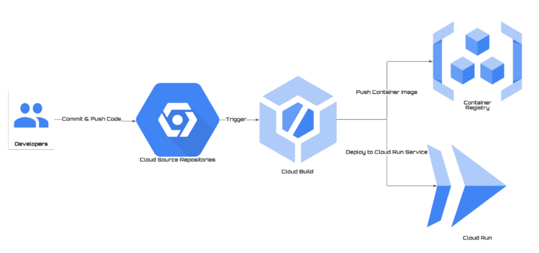

**Learn More**

•  [**GCP Cloud Deploy Documentation**](https://cloud.google.com/deploy/docs) – Official guide on how to set it up and use it.

• [**Introduction to Google Cloud Deploy**](https://cloud.google.com/free/?utm_source=bing&utm_medium=cpc&utm_campaign=japac-IN-all-en-dr-bkws-all-all-trial-p-dr-1009882&utm_content=text-ad-none-none-DEV_c-CRE_-ADGP_Hybrid+%7C+BKWS+-+PHR+%7C+Txt+~+GCP_General_google+cloud+platform_main-KWID_43700079) – Blog post that explains the basics.